**Chapter 13: Manipulating Text**

**Command Line Tools for Manipulating Text Files:** Irrespective of the role you play with Linux (system administrator, developer or user), you often need to browse through and parse text files, and/or extract data from them. These are file manipulation operations. Thus, it is essential for the Linux user to become adept at performing certain operations on files.

Most of the time, such file manipulation is done at the command line, which allows users to perform tasks more efficiently than while using a GUI. Furthermore, the command line is more suitable for automating often executed tasks.

Indeed, experienced system administrators write customized scripts to accomplish such repetitive tasks, standardized for each particular environment. We will discuss such scripting later in much detail.1

In this section, we will concentrate on command line file and text manipulation-related utilities.

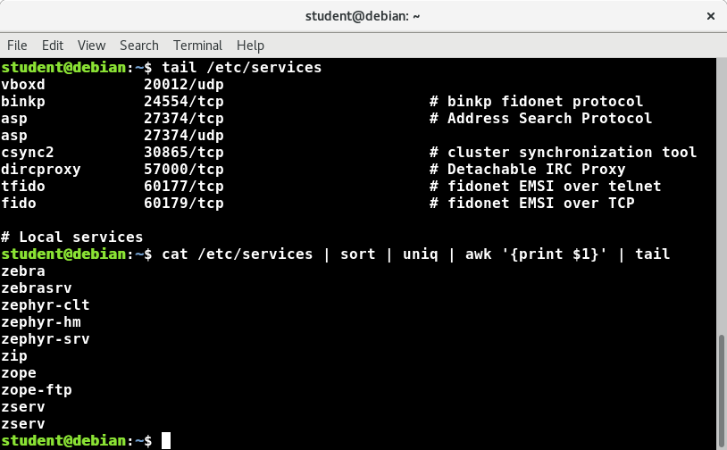

**Cat:** cat is short for concatenate and is one of the most frequently used Linux command line utilities. It is often used to read and print files, as well as for simply viewing file contents. To view a file, use the following command:

$ cat <filename>

For example, cat readme.txt will display the contents of readme.txt on the terminal. However, the main purpose of cat is often to combine (concatenate) multiple files together. You can perform the actions listed in the table using cat.

The tac command (cat spelled backwards) prints the lines of a file in reverse order. Each line remains the same, but the order of lines is inverted. The syntax of tac is exactly the same as for cat, as in:

$ tac file

$ tac file1 file2 > newfile

|  |  |
| --- | --- |
| **Command** | **Usage** |
| **cat file1 file2** | Concatenate multiple files and display the output; i.e. the entire content of the first file is followed by that of the second file |
| **cat file1 file2 > newfile** | Combine multiple files and save the output into a new file |
| **cat file >> existingfile** | Append a file to the end of an existing file |
| **cat > file** | Any subsequent lines typed will go into the file, until **CTRL-D** is typed |
| **cat >> file** | Any subsequent lines are appended to the file, until **CTRL-D** is typed |